26.92:
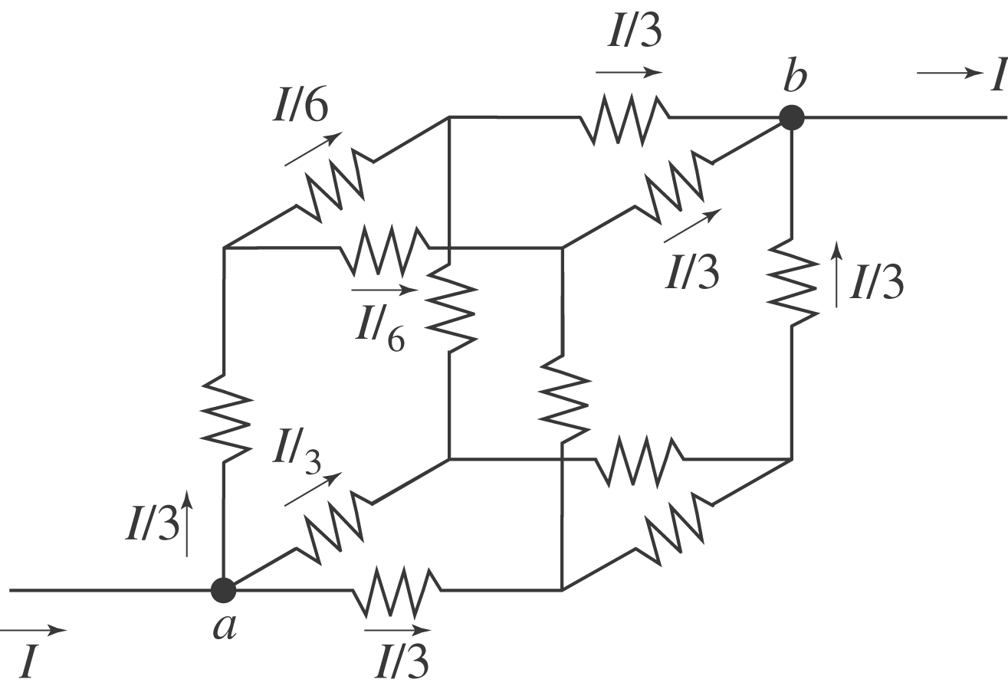
Let current 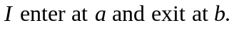 At there are three equivalent branches, so current is 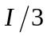 in each. At the next junction point there are two equivalent branches so each gets current 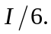 Then at there are three equivalent branches with current in each. The voltage drop from 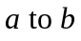 then is 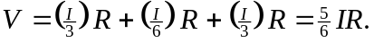 This must be the same as 